**Lab Exercise 4– Terraform Variables**

Objective:

Learn how to define and use variables in Terraform configuration.

Prerequisites:

• Install Terraform on your machine.

Steps:

**1. Create a Terraform Directory:**

**• Create a new directory for your Terraform project.**

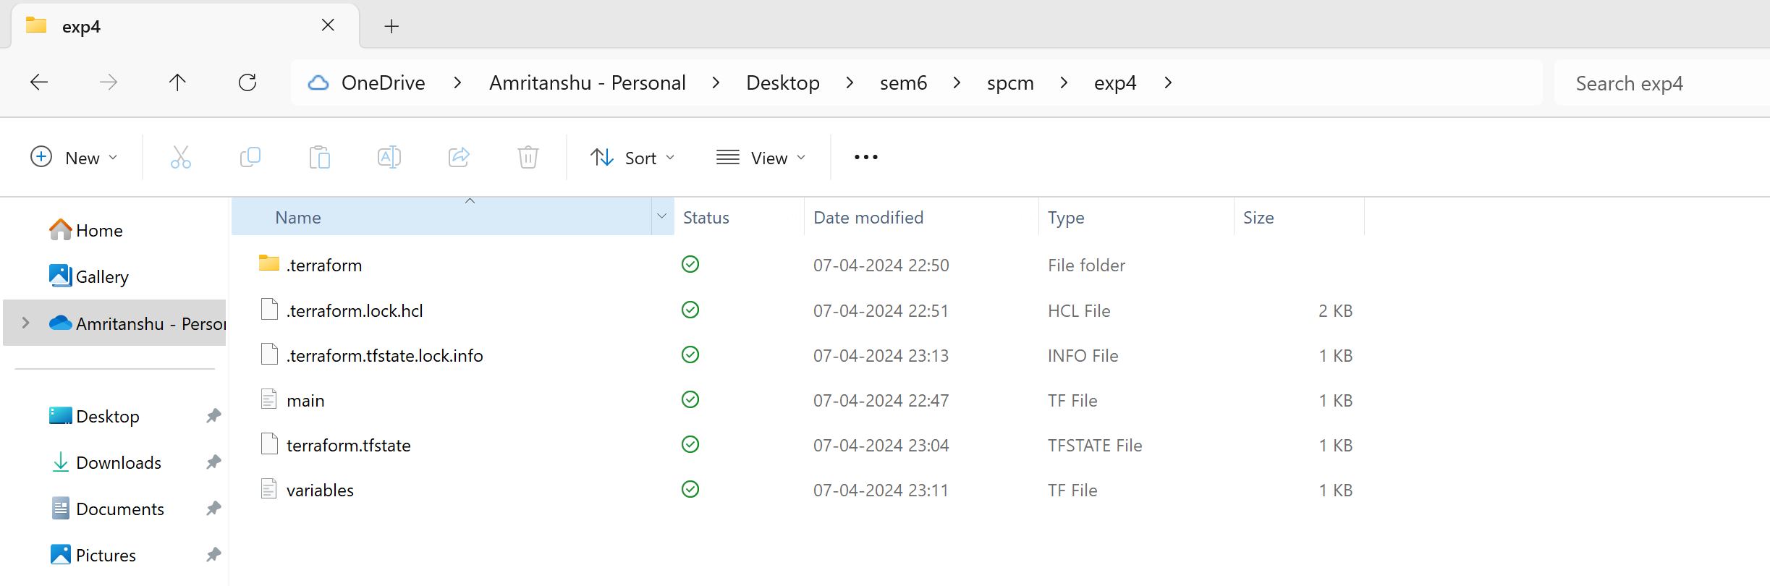

**2. Create a Terraform Configuration File:**

**• Create a file named main.tf within your project directory.**

**# main.tf**

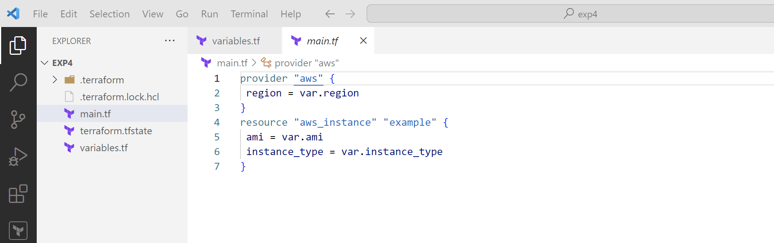

**3. Define Variables:**

**• Open a new file named variables.tf. Define variables for region, ami, and**

**instance_type.**

**# variables.tf**

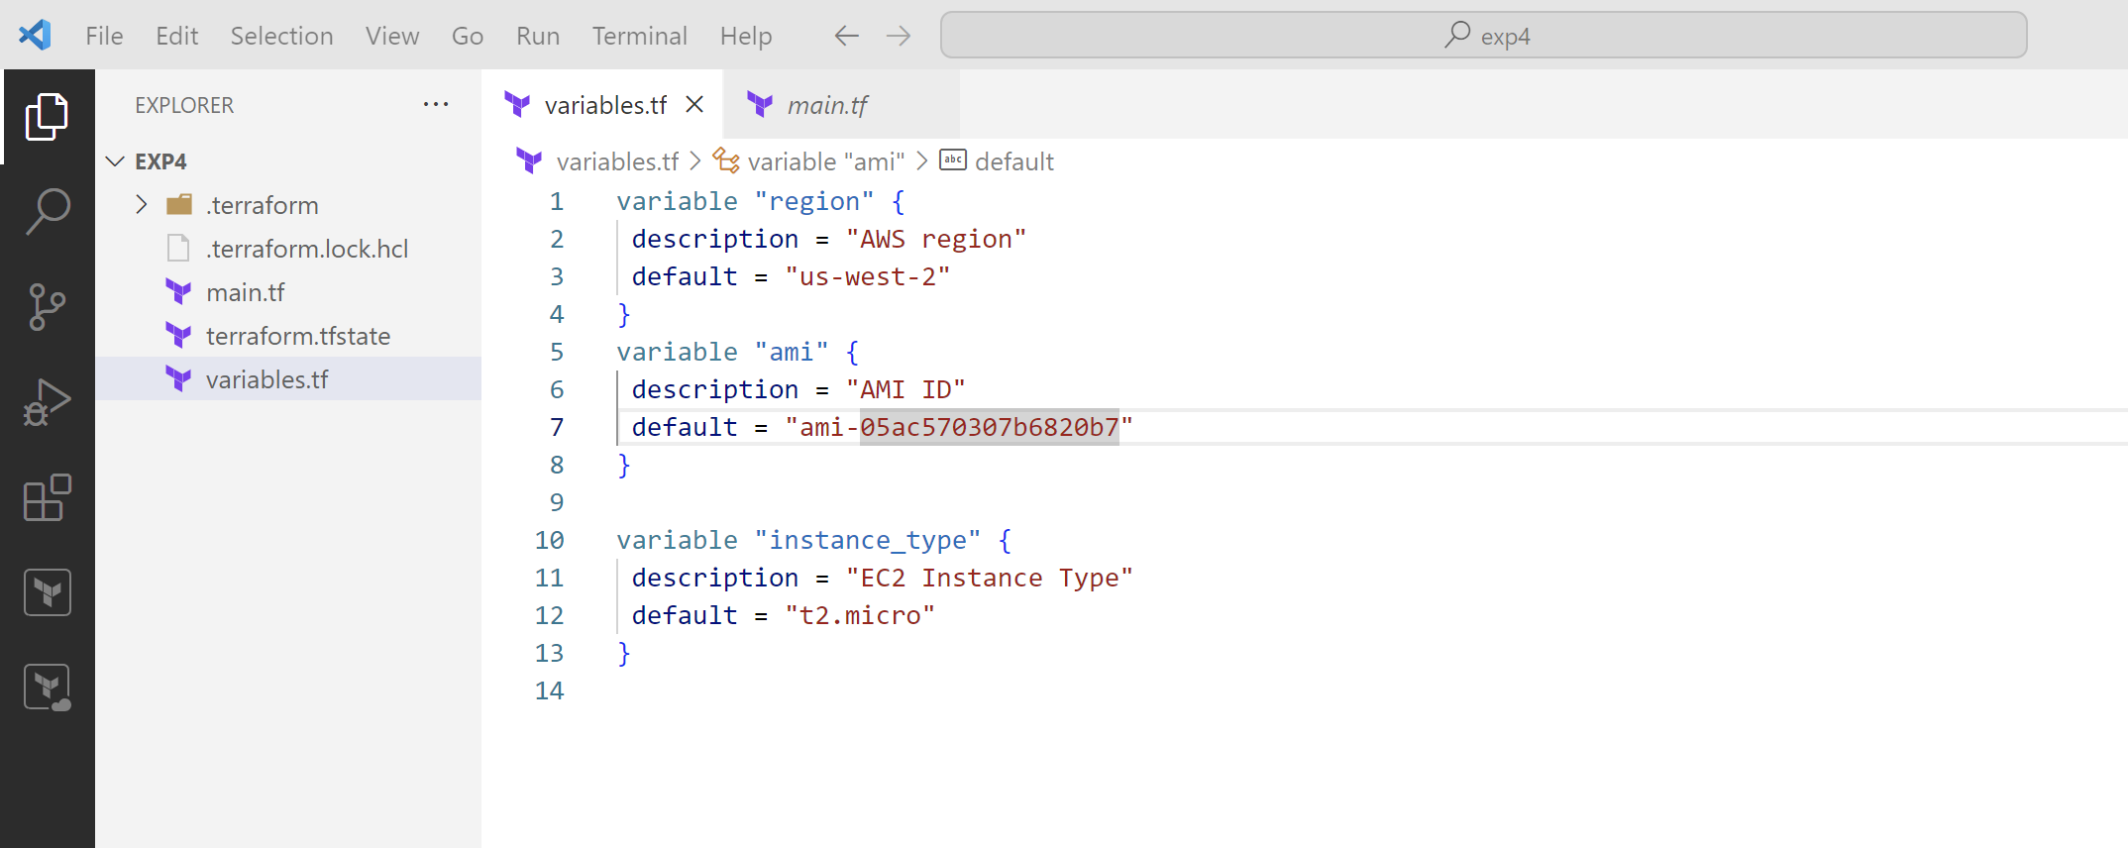

**4. Use Variables in main.tf:**

**• Modify main.tf to use the variables.**

**# main.tf**

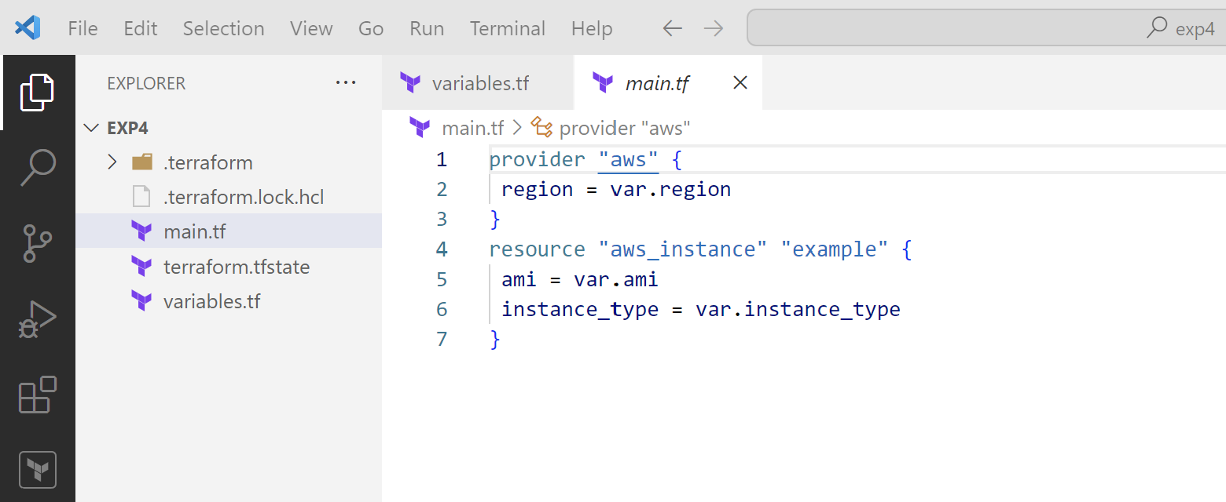

**5. Initialize and Apply:**

**• Run the following Terraform commands to initialize and apply the**

**configuration.**

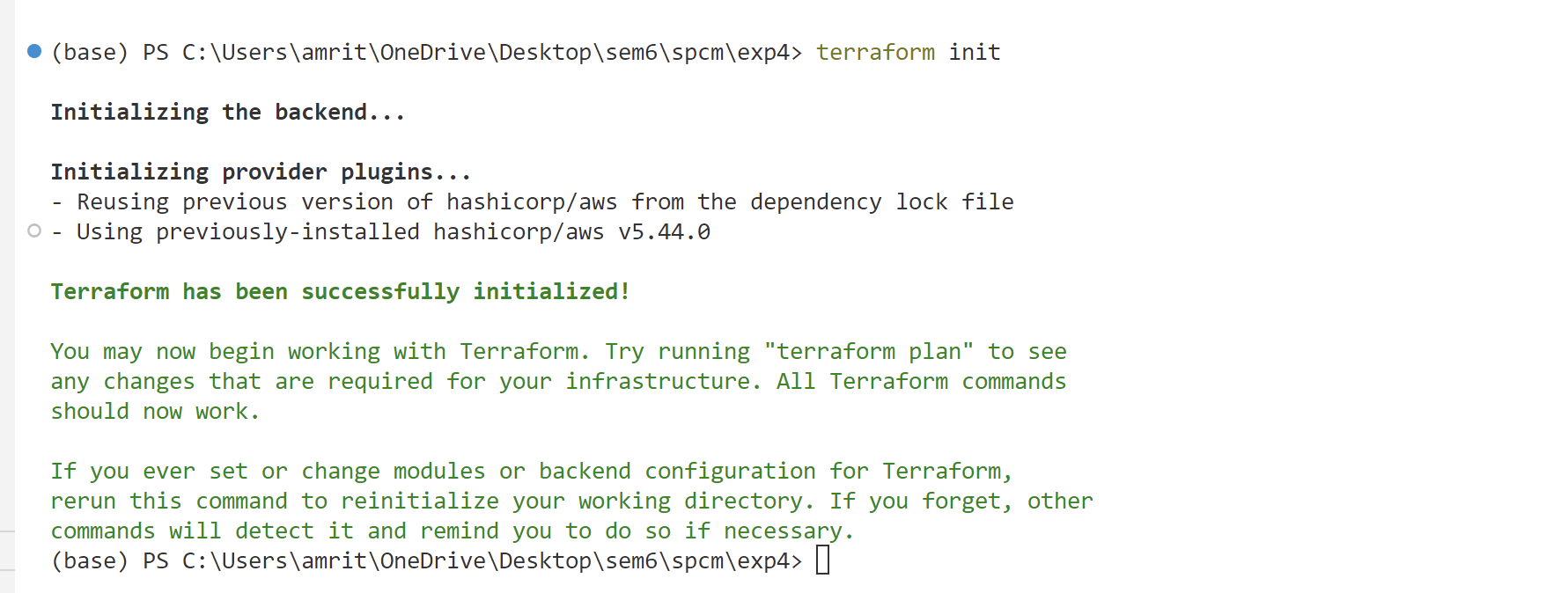

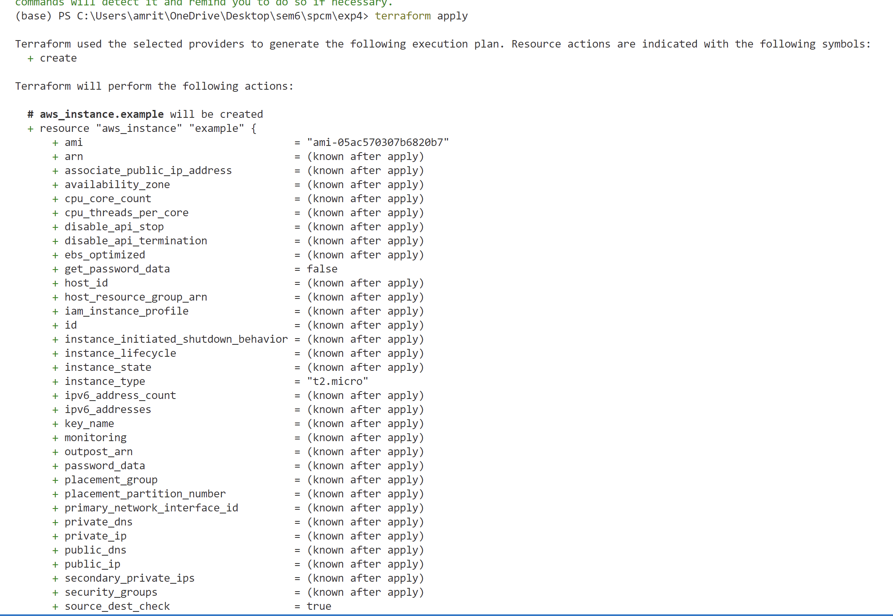

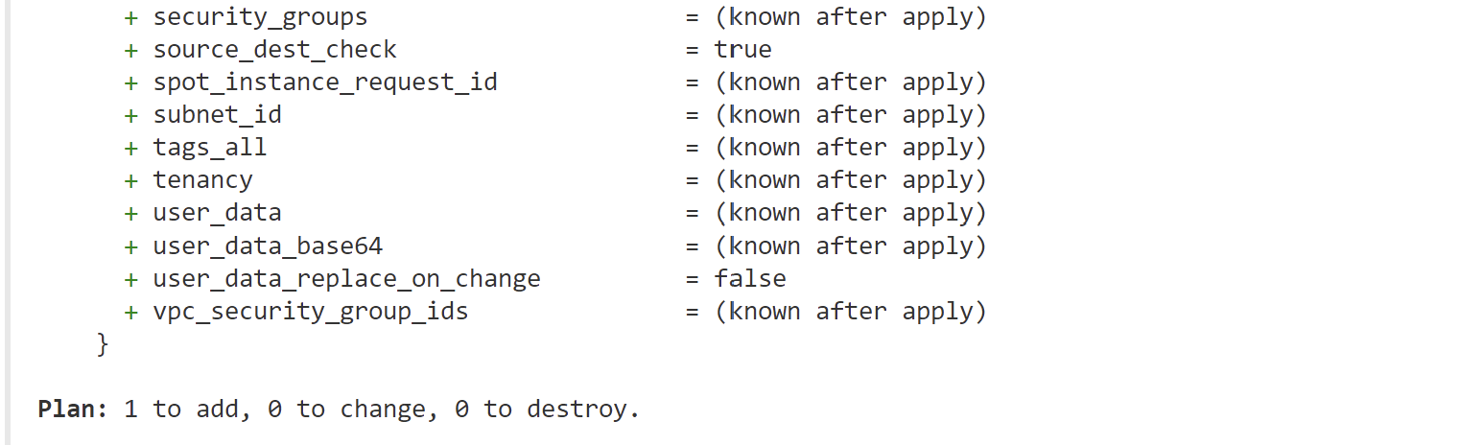

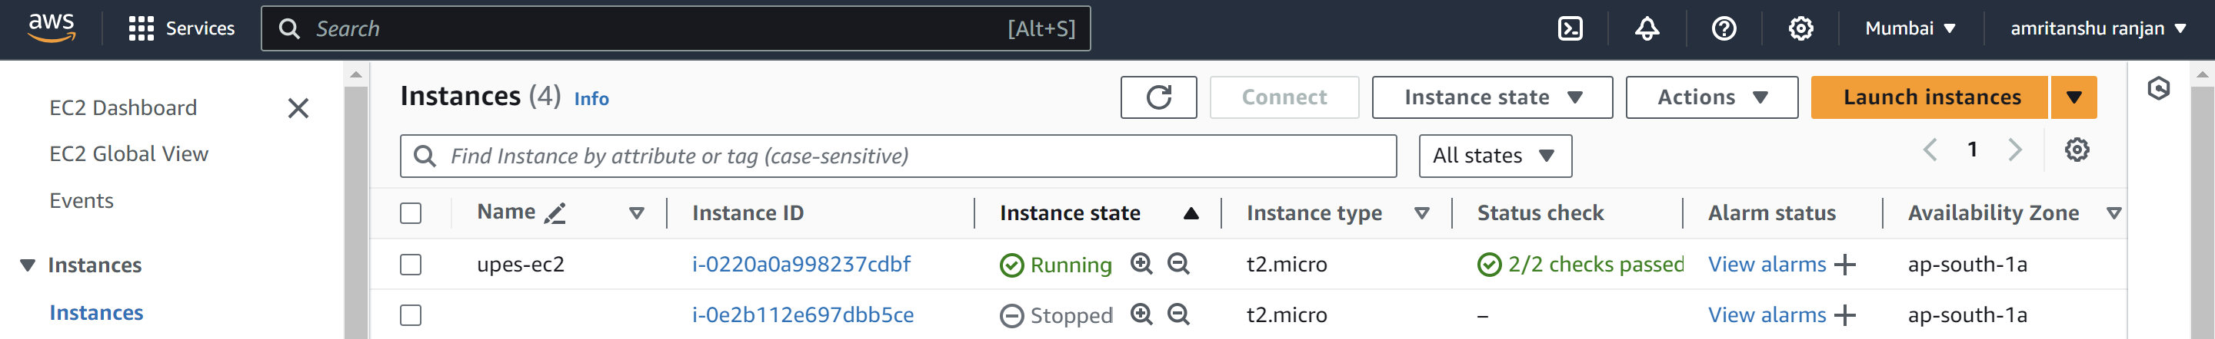

**6. Clean Up:**

**After testing, you can clean up resources**

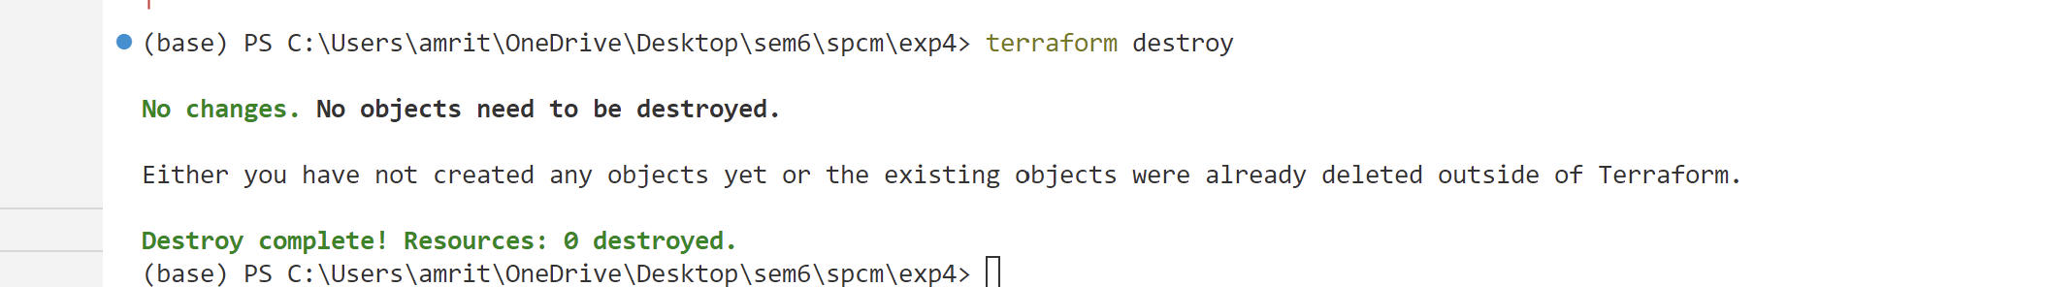.



Confirm the destruction by typing yes.

**7. Conclusion:**

This lab exercise introduces you to Terraform variables and demonstrates how to use

them in your configurations. Experiment with different variable values and overrides

to understand their impact on the infrastructure provisioning process.